- Make color choice of your own and fill them between the lines
- Be meditative and mindful when you are coloring: let go of what happened that day
- The provided pattern is an essential element, other elements can be added to your whole design.
- Give your artwork a name that you feel connected

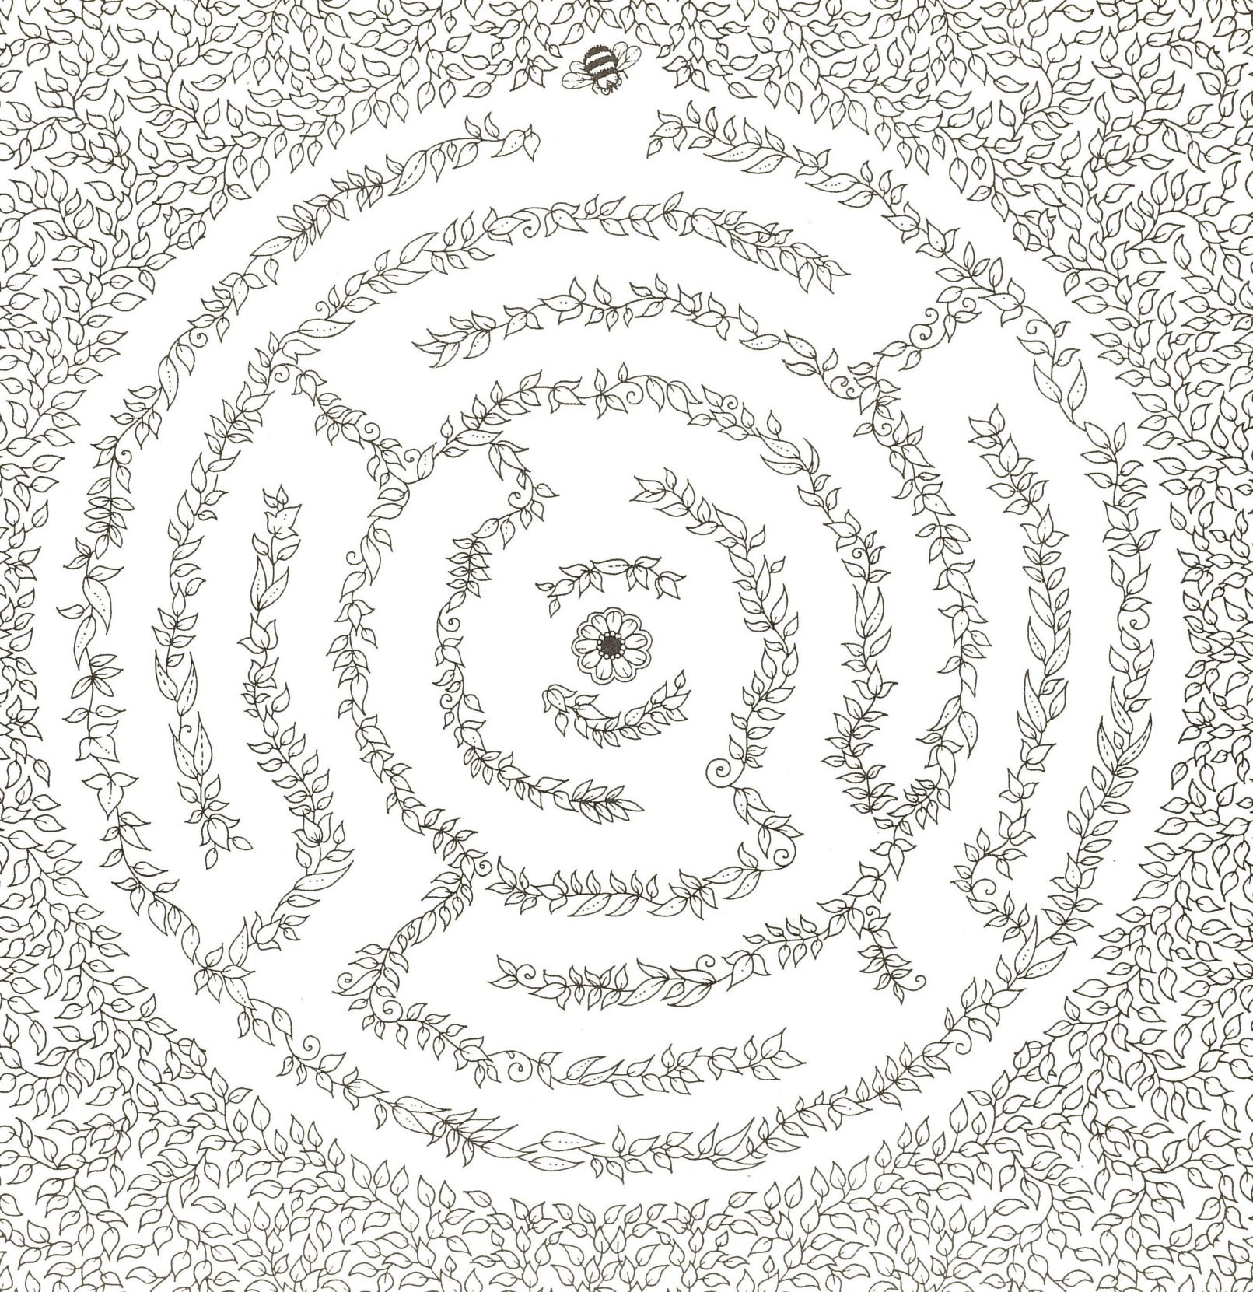

Student Name (in print):_____________________ Student ID Number:___________________
Name of the work:___________________________________________________________________________
Anything you want to share about doing this:______________________________________________________
___________________________________________________________________________________________

