学生用户使用指南
- 登录微信
Login WeChat
- 搜索打开小程序“江苏图采”，或关注“江苏省招就中心”公众号，选择“服务指南”中“图像采集”项目
Fill your personal information:
Option 1: search "江苏图采" and open the mini program
Option 2: follow WeChat account of "江苏省招就中心", and select the "服务指南"-“图像采集”.
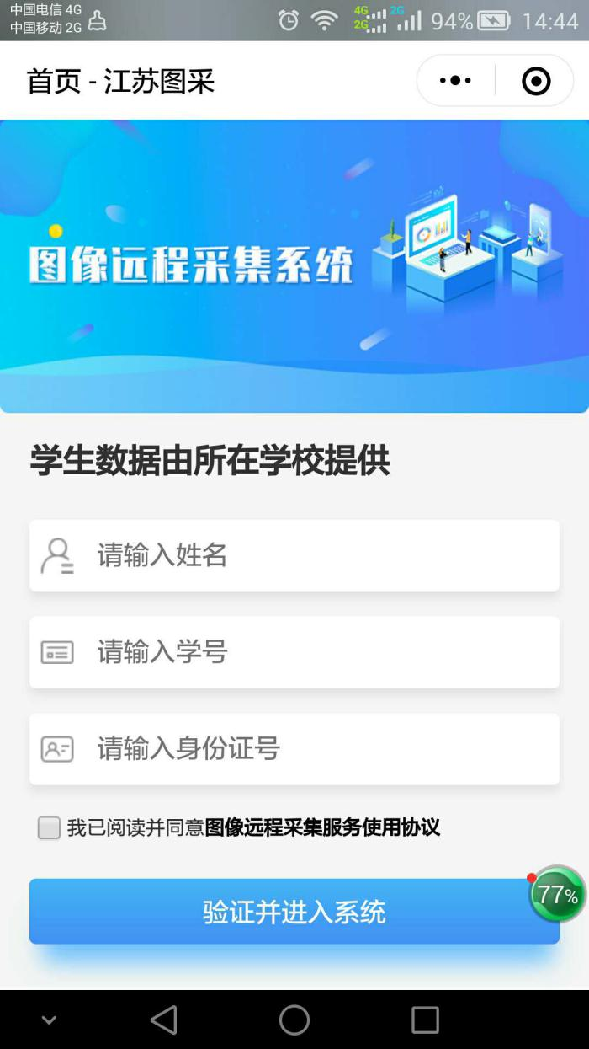

- 实名验证通过后，按步骤操作。（如报错，可根据提示联系教务处学籍科，联系电话：88797585，毕业生图像采集QQ群：720941492）
After the verification of your personal information, please follow the following steps.
- 手机号录入
Register your phone number

- 阅读学校图采通知
Read the notice of photo collection
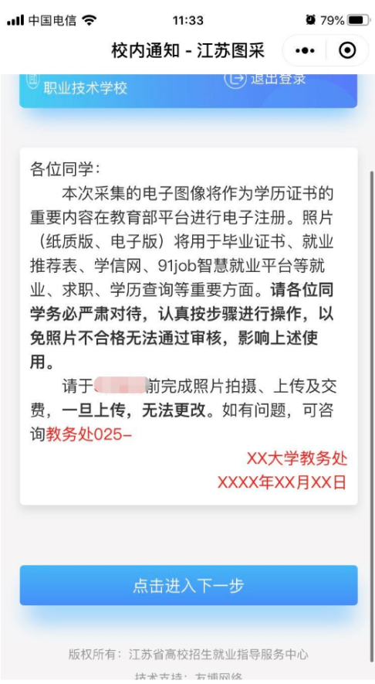
- 阅读注意事项
Read the tips
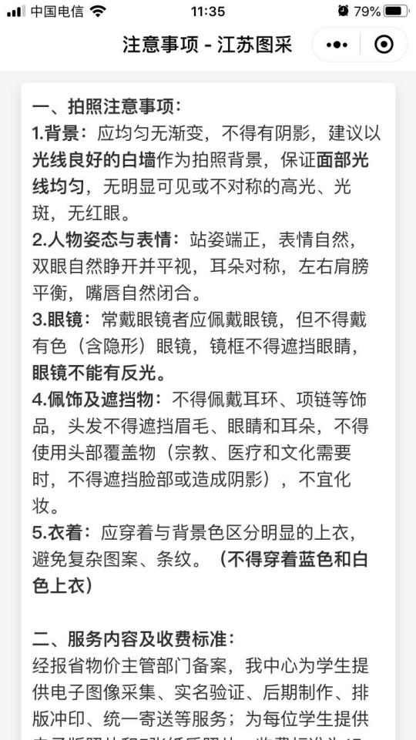
- 浏览拍摄要求
Read the requirements for photo taking
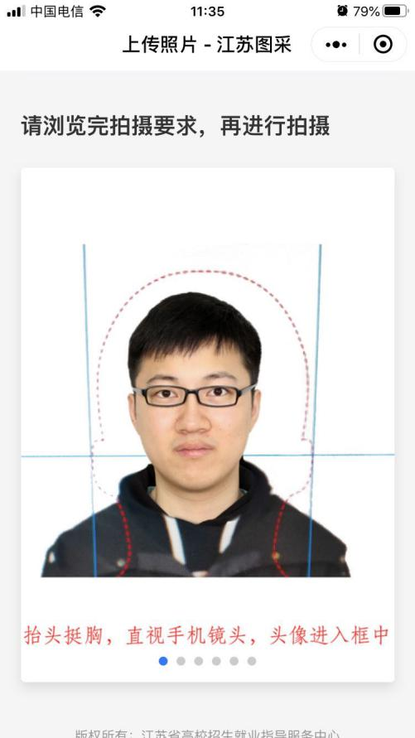
- 在“拍摄要求”最后一页点击拍摄
Click “点击拍摄”in the last page of “拍摄要求”
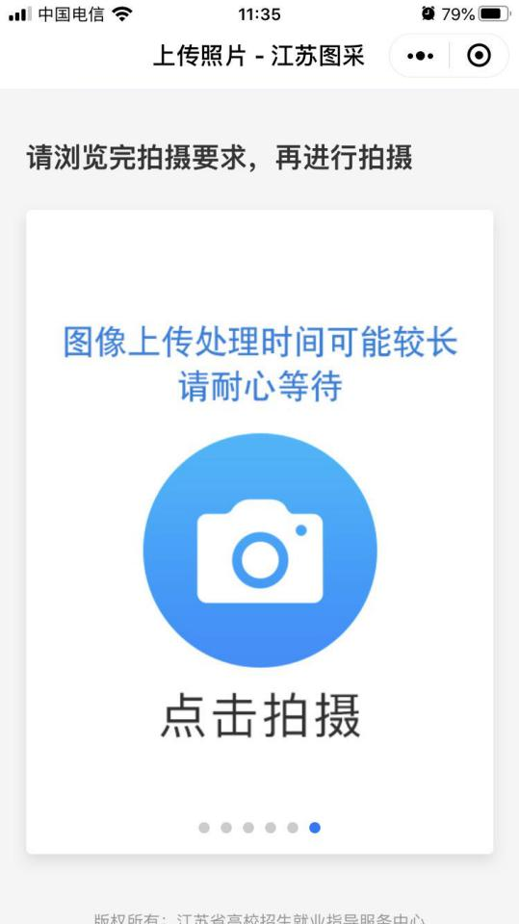
6）拍摄符合要求的照片，严禁翻拍，严禁美颜。
Strictly follow the requirements while taking the photo. Please DO NOT remake or beautify!

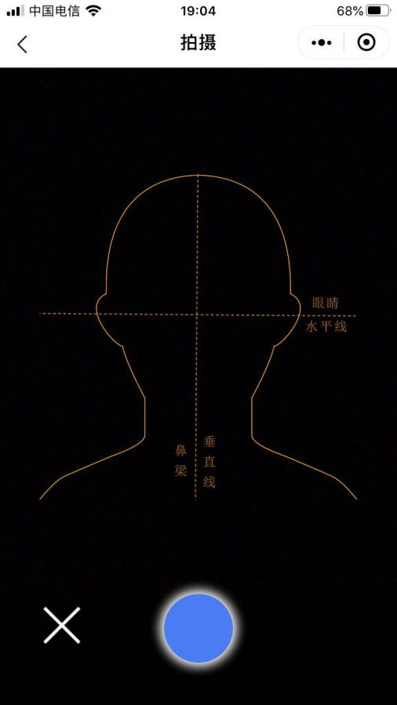
7）等待系统返回处理好的照片，确认上传前如不满意，请点击下方相机按钮重新拍摄，直到满意后上传，一旦上传即为定稿，无法更改。
Please check the photo after it is processed by the system. Before uploading, if you are not satisfied with the photo, you can click the camera button below to take again until you are satisfied. Once uploaded, it would be considered as the final one and cannot be changed any more.
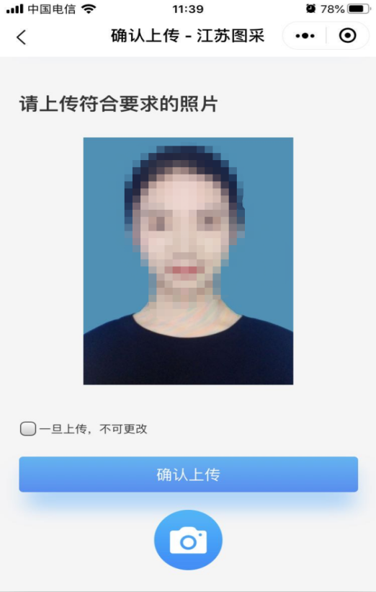
8）照片下载页，如系统已经制作完成，则“照片下载”处可以点击下载图片。
In photo download page, if the photo has been completed, click "照片下载 " to download the photo.
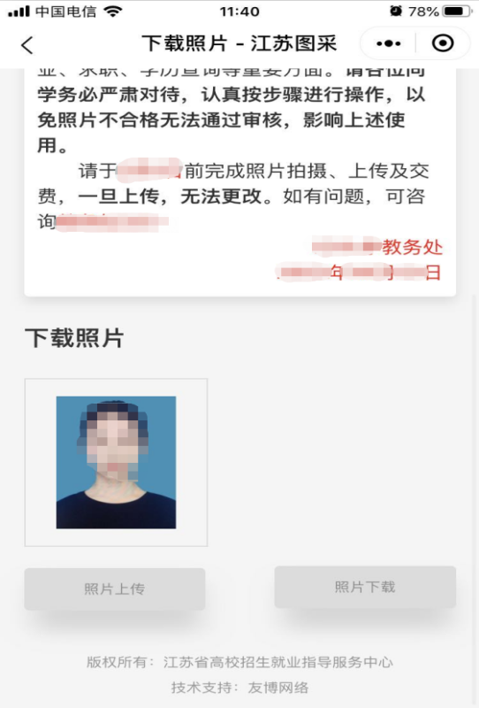

- 常见不合格照片及解决办法
Common problems of the photo-taking and related solutions
问题一：脸部光线不均匀，一边亮一边暗。
解决办法：面对光源较好的方向，确保脸部光线均匀。
Problem 1: The uneven light makes part of the face bright and part dark at the same time.
Solution: Choose the suitable place which has even light for photo-taking.
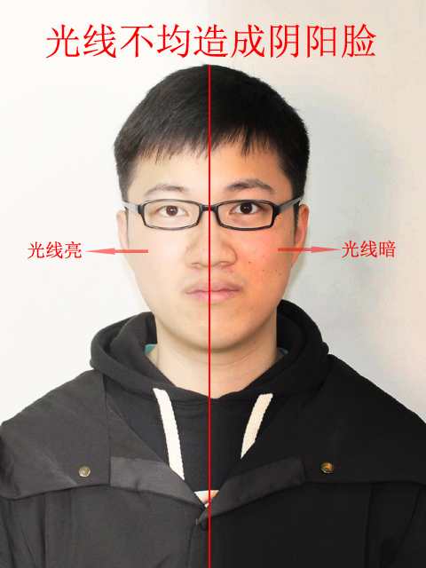

问题二：翻拍其他照片或过度美颜。
解决办法：拍真实的自己，证件照注重真实性，严禁美颜处理，严禁翻拍。
Problem 2: Remake other photos or over beautify.
Solution: take real photos of yourself, pay attention to the authenticity of certificate photos. Do not beautify or remake.
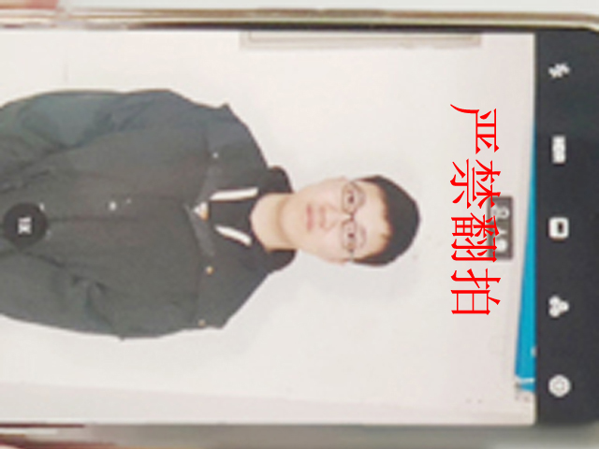

问题三：图像模糊。
解决办法：拍照前擦拭手机后置摄像头，拍照时保持手机稳定，拍照后点击查看。
Problem 3: Image blur.
Solution: Clean the rear camera of the mobile phone before taking photos, keep the mobile phone stable when taking photos, and click to check it after taking photos.
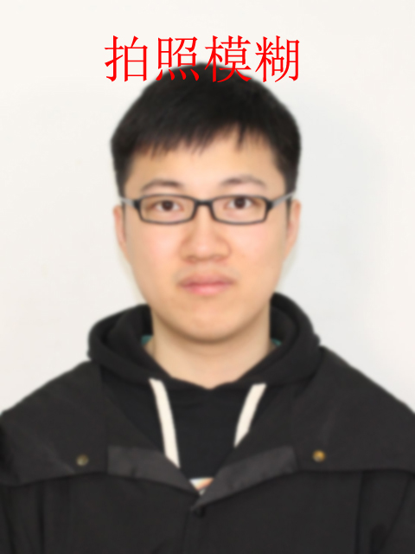

问题四：脸部光线过强造成曝光过度。
解决办法：避免用闪光灯或在强光直接照射的地方拍照。
Problem 4: Overexposure caused by too much light on the face.
Solution: Avoid taking pictures with flash or the direct strong light.
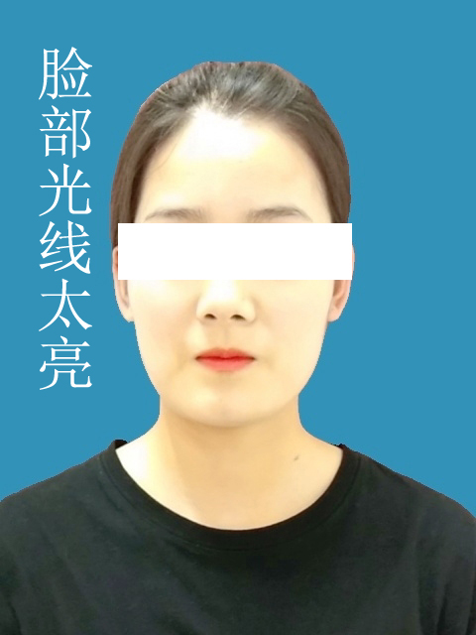

问题五：头顶灯光太强，导致发色异常。
解决办法：避开直接在灯光下拍照。
Problem 5: The overhead light is too strong, resulting in abnormal hair color.
Solution: Avoid taking pictures directly under the light.
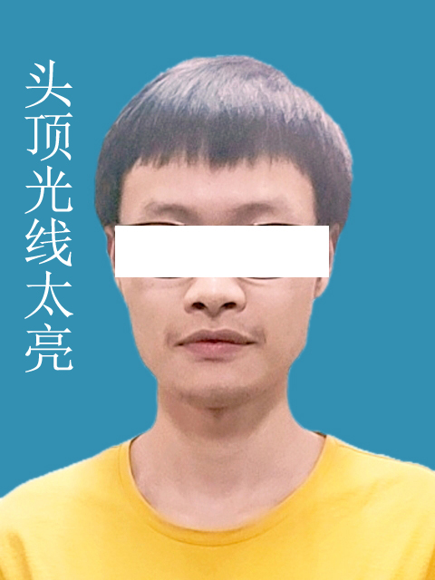

问题六：脸部光线太暗。
解决办法：找一个光线良好的拍照环境拍摄。
Problem 6: The light is too dark.
Solution: Choose a place with good light.
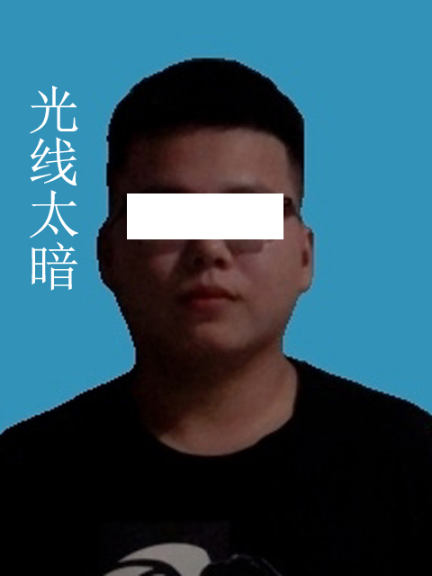

问题七：拍照时不应拍全身照，造成图像太小。
解决办法：拍照时将头部、肩膀对应放入“人形虚线取景框”后再拍摄。
Question 7: Do not take full-body photos as it might cause the image too small to process.
Solution: Make sure that the image of your head and shoulder is placed into the "dotted man frame" before taking photos.
